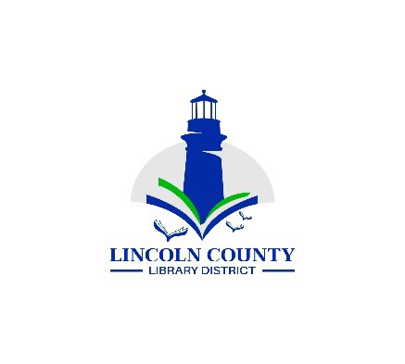
Lincoln County Library District Board Regular Meeting
Wednesday, November 12, 2025
132 NE 15th Newport, OR 97365
Present: Chris Boyle, chair; Carla Clark, vice-chair (via zoom), Susan Garner, Tim Merrell, Virginia Tardaewether (via zoom), Bryan Miyagishima, secretary

Agenda
Call Regular Meeting to Order |  | President | - Meeting called to order at 10:05AM
Approval of the Agenda |  | President
Topic | Lead |  | Purpose Outcome
Public Comment | President |  | Anyone may speak at this time
Minutes  Board Meeting October 15, 2025 | President |  | Approval  Motion to approve: Susan, second: Tim / approved unanimously
Reports
Board Reports | Board Members |  | Information - no reports
Director’s Report | Director |  | Information – in packet
Financial Report | Director |  | Acceptance
Old Business
Library funding formula | President |  | Approval – Motion to approve: Tim, Second: Susan / approved unanimously. Dollar amounts will be approved in December meeting. The chart on page 4 of the formula will be fixed to reflect correct zip codes.
Library agreement with cities | Director |  | Update – Bryan inquired of SDAO legal services and was referred to outside legal counsel. Am awaiting response.
Bryan’s appraisal | Director |  | Update  Video training: https://tinyurl.com/lcldassess  Executive Director Evaluation  Performance Management Resource Guide  Carla and Virginia and Susan agreed to participate in the appraisal process. Bryan will convene a first meeting.
New Business
Direct grants to libraries | Director |  | As part of its strategic plan, the District will create a process for distributing surplus tax revenue as direct grants to libraries.  Bryan will have a application for review at the December meeting. Proposals should ideally address elements of the District’s strategic goals.
Good of the Order
Next District Board  Meeting  December 10, 2025 |  |  | Information
Adjourn | President |  | Motion – adjourned at 11:06AM

