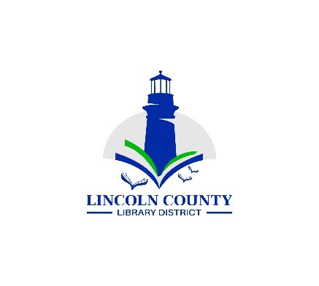
Lincoln County Library District Board Regular Meeting
Wednesday, November 12, 2025
132 NE 15th Newport, OR 97365

Agenda
Call Regular Meeting to Order |  | President
Approval of the Agenda |  | President
Topic | Lead |  | Purpose Outcome
Public Comment | President |  | Anyone may speak at this time
Minutes  Board Meeting October 15, 2025 | President |  | Approval
Reports
Board Reports | Board Members |  | Information
Director’s Report | Director |  | Information
Financial Report | Director |  | Acceptance
Old Business
Library funding formula | President |  | Approval
Library agreement with cities | Director |  | update
Bryan’s appraisal | Director |  | Update  Video training: https://tinyurl.com/lcldassess  Executive Director Evaluation  Performance Management Resource Guide
New Business
Direct grants to libraries | Director |  | As part of its strategic plan, the District will create a process for distributing surplus tax revenue as direct grants to libraries.
Good of the Order
Next District Board  Meeting  December 10, 2025 |  |  | Information
Adjourn | President |  | Motion

